Assignment Part-3

1. Create a file like nano file1.txt

o Edit some data and then save the file

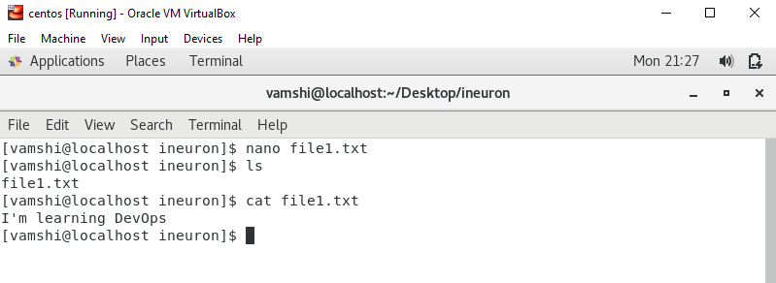

1. Now we will copy date from file1 to new file2

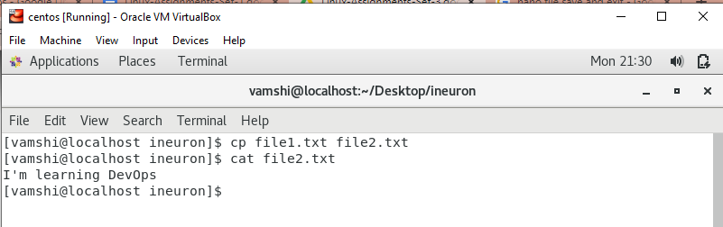

1. Now we will move the file2.txt to new folder /home

o mv file2.txt /home

o Then go to home directory and check ls, file exits or not?

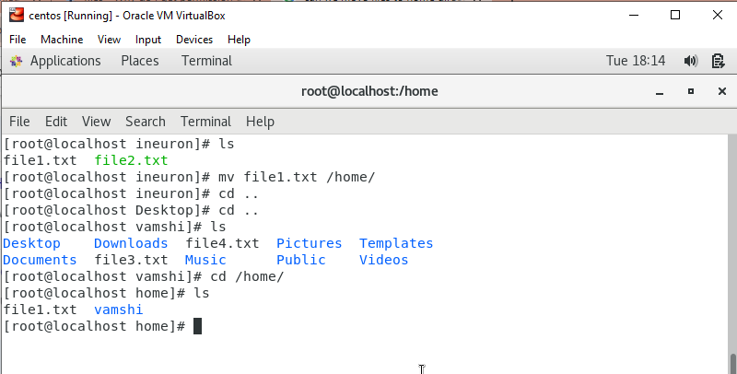

1. Then we create a new file3.txt and file4.txt in home directory and add

content in it.

o Now do echo “Hello I am newline” > file3.txt and provide the output of file3.txt

**Explanation**: To overwrite a file use > I.e, its overriding on the existing content and updating new content in a file.

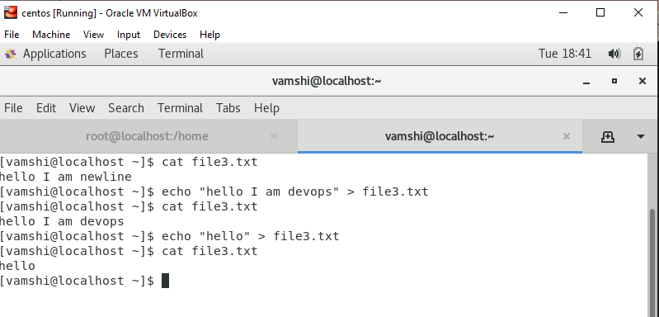

o Now do echo “Hello I am newline” >> file4.txt and provide the output of file4.txt

**Explanation:** To append a file use >>. Append means simply add the data to the file without erasing existing data.

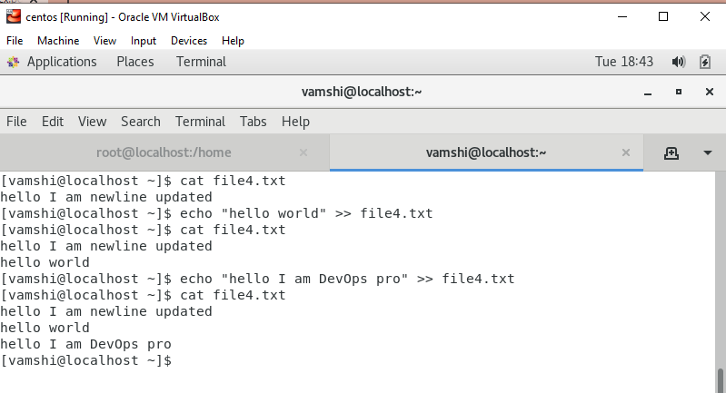

1. For remove a file or directory you can use the below two commands  
    o To delete a file – rm <any_filename>

O To delete a directory -rmdir <any_directoryname>

